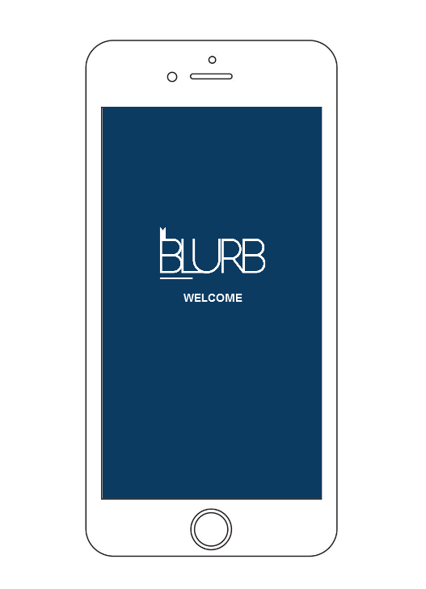

BLURP Book Retailer Report

Coursework 2

Group 5 | Mobile User Experience| 11/12/2017

# Introduction

Group 5 was consisted of 4 members as follows: Calvin Keesoony (Student 1, iPhone portrait orientation), Sam Collins (Student 2, iPhone landscape orientation), Haresh Vekryia (Student 3, iPad portrait orientation) and Madalina Voiniciuc (student 4, iPad landscape orientation).

We chose to design and implement the second concept, Book retailer Web App, as we considered it would be more challenging to develop an education related program than a fashion one. Also, after listening to some discussions within the class, we observed that most of our colleagues tend to embrace the other approach of the project so we thought it would be a good opportunity to come forward.

From the beginning we tried to establish a regularity as regards our group meetings in order to bring together our work even if each of us tried to concentrate to finish our parts and always be in time with the schedule we set.

After we received the feedback for the first coursework we decided to take into consideration the suggestions so we end up having a quite different website to the one we made prototypes for.

As regards the differences between iPhone and iPad, there are a few important ones, for example, we decided to add icons on the list of items (Stores, Events, Team Members) when the website is opened in iPad while in the iPhone device we tried to make it less crowded as there was already a lot of content to display. In the matter of orientations, the differences between iPad portrait and iPad landscape are almost unnoticeable because we tried to have a sequence of the steps while doing a task on the website so that the user would not feel any discrepancy of the design unless the size of the screen is changed considerably. Overall in our designs across both iPad and iPhone we wanted to keep the structure and how we formatted both designs universally the same, so our implementations for our pages share a lot of similarities amongst them regarding the CSS implemented.

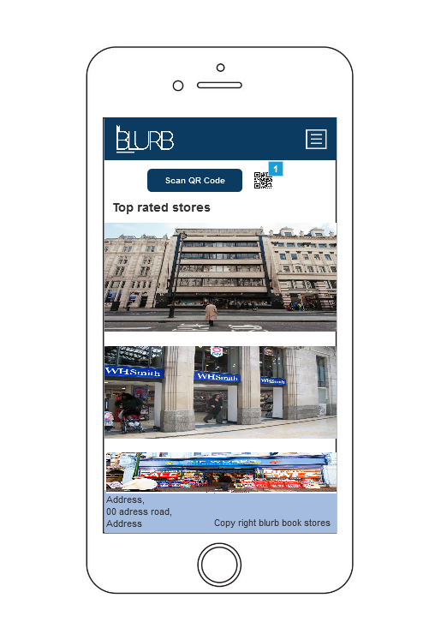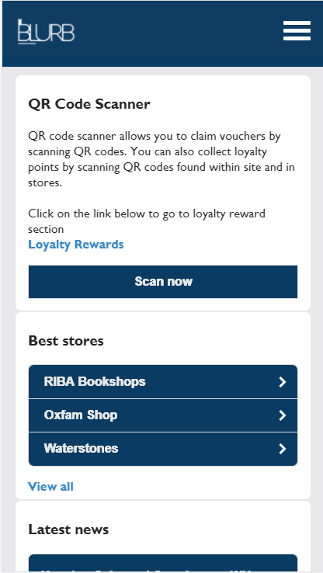

The Home page on iPhone portrait (Implemented)

The Home page on iPhone portrait (Prototype)

# Group_5_Student_1_iPhone

I was responsible for: intro page, points of interest’s list, providing information about each poi, implementing google maps for the poi’s, favourites list for poi, booking form, and template creation for iPhone portrait.

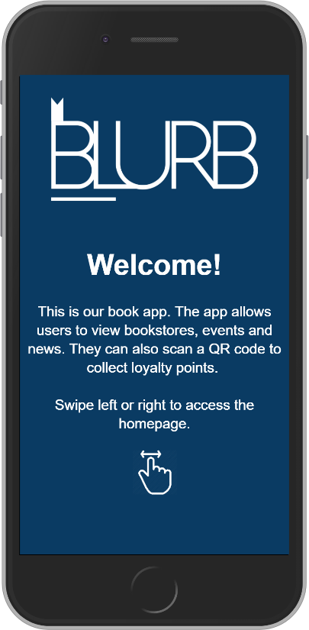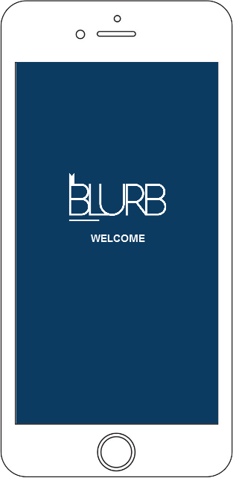

**Intro Page**

The prototype shows that the blurb logo is centred and displayed the welcome message below. The background is dark blue and the content is white. The welcome message just says ‘welcome’.

The final design has a background which is dark blue and the logo which is white. A ‘slidefade’ transition is used when the page is opened and then displays the content. This was done by jquery. The welcome message says ‘welcome’ and includes a summary of the app. The interactive aspect of this page is that users can swipe either left or right in order to access the homepage, which was done by jquery. An icon is displayed at the bottom, indicating that users are able to swipe the screen. The colour scheme remains white and blue from the prototype. The font is arial and the font size is 20px. I’ve decided to make the ‘welcome’ message a header as it’s meant to stand out whereas the summary remains the normal font type.

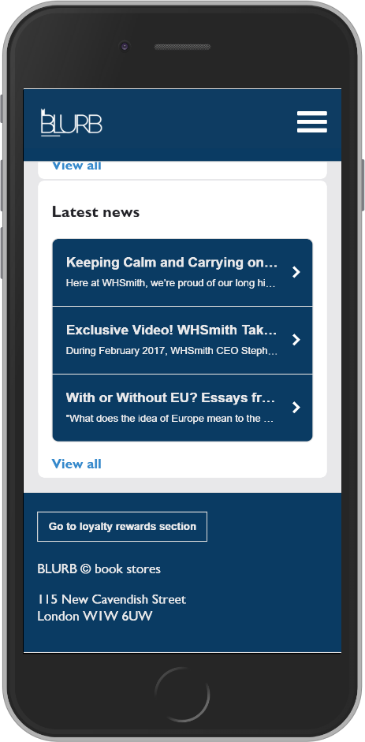

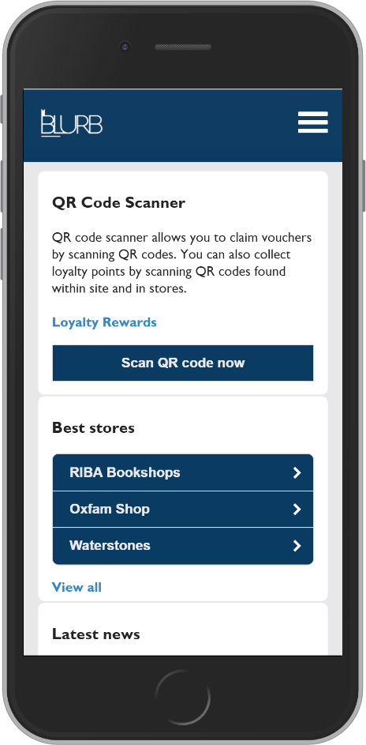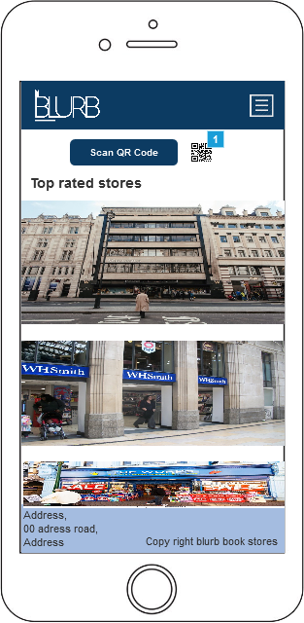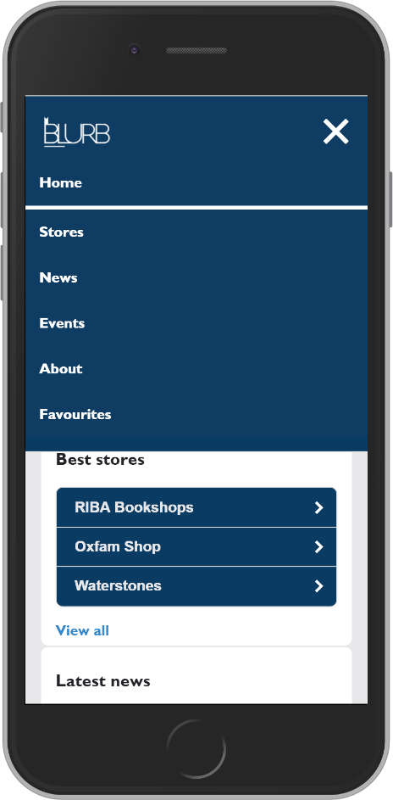

**Home Page & Navigation**

The prototype shows the logo on the top left while the menu is on the top right. A scan qr code button along with a qr code symbol is shown below the navigation. This button would redirect users to the scan qr page. The sections displayed are top rated stores, best stores and latest news. Users would have to scroll in order to view them. The top rated and best stores displayed images of the stores and would be used as hyperlinks which would redirect them to the information page of that store. The footer is light blue and contains the address of the university and the copyright on the bottom right.

The final design of the homepage contains a section about the qr scanner. The reason for this is because I have included a description of what the scanner does and how its beneficial to the user. There is also a button to atrivate the scanner and hyperlink above which redirects the user to the loyalty rewards page. There is another section called best stores. This displays the three stores along with a arrow which indicates that the user can view more information on a certain store along with a view all link at the bottom of each section. The footer is dark blue and contains a button which redirects the users to the loyalty page, blurb copyright information and university address.

The last section is called latest news. This shows three articles which also include the arrow, this allows users to view more infromation on a certain article. In the footer there is a button which redirects the user to the loyalty rewards page. The font type is Calibri and the font size is 1.4em which is the same throughout the app.

The navigation uses a hamburger style naviagtion, it contains filters and the logo is displayed in the navigation bar. The ‘BLURB’ logo redirects users to the homepage. The naviagtion contains six pages which are homepage, stores (poi), news, events, about and favourites.

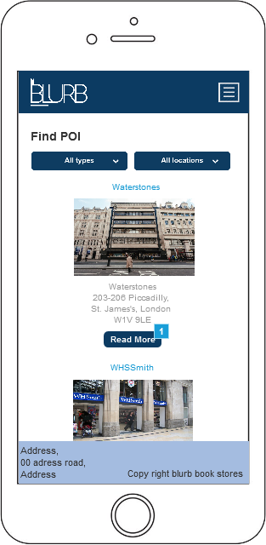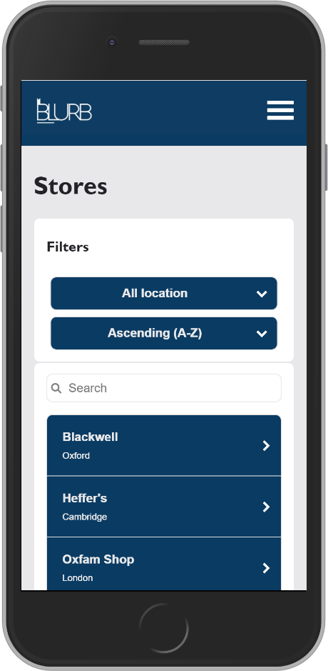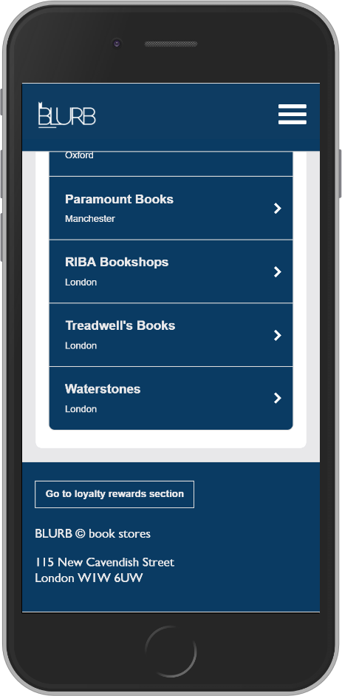

**Stores Page (POI)**

The prototype contains two filters which show the type and location of the poi’s. The name of the poi is centered and the image of the poi will be shown below it. The address of the poi is shown below the image. There is a ‘read more’ button which would redirect users to the poi information page.

The final design contains two filters which were done by javascript. They are location (cities) and order (ascending or desecending). The background is blue while the information is white. In addition to the prototype, we have added a search bar which allows users to search by either city or store name, which was done using javascript. The stores are displayed as a list which include the store name, location and an arrow which redirects users to the information page about a specific store.

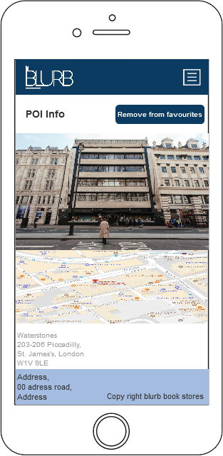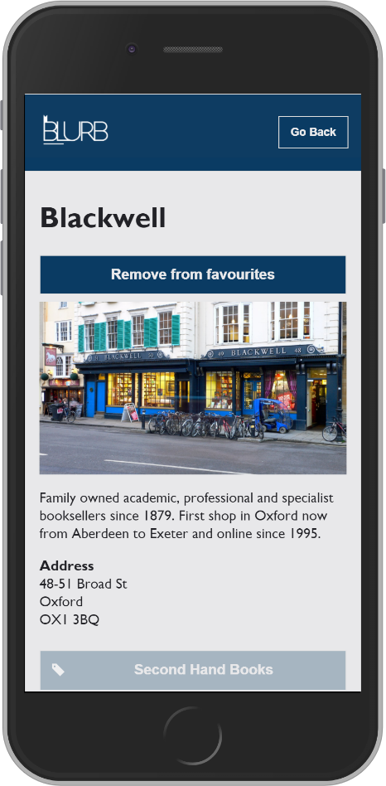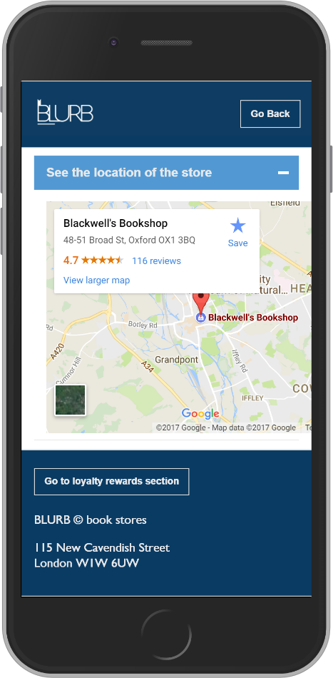

**Stores Information**

The prototype shows the image of the poi, address of the poi and the location below it via google maps. There is a button displayed on the top right corner which allows users to add this to their favourites list.

The stores information page contains a button, which allows users to add the store to their favourties list. Users are able to view their favourties list, on the favourties page. There is a image of the whole store building as oppose to a close up, because users will get an idea of the area and may recognise certain streets. Below the image is a description of the store, the address of the store, services they offer which are displayed as labels and a collapsable list which shows the location of the store via Google Maps which had the script on there website. There is back button displayed in the navigation which redirects users back to the stores page.

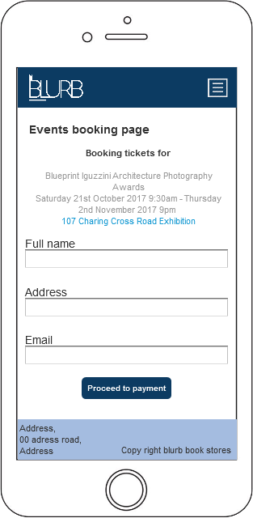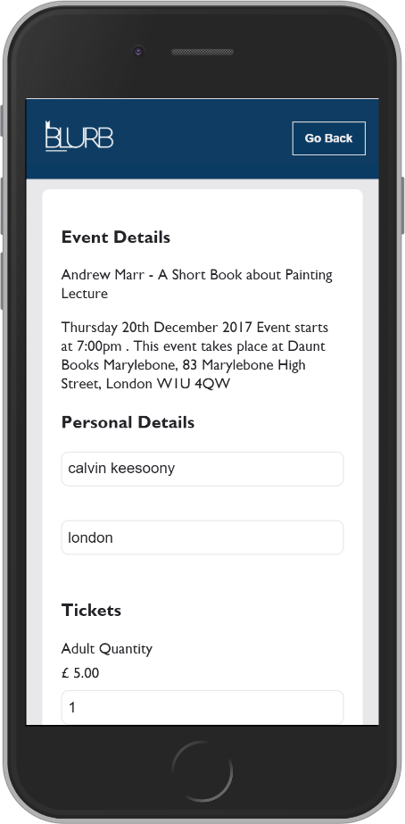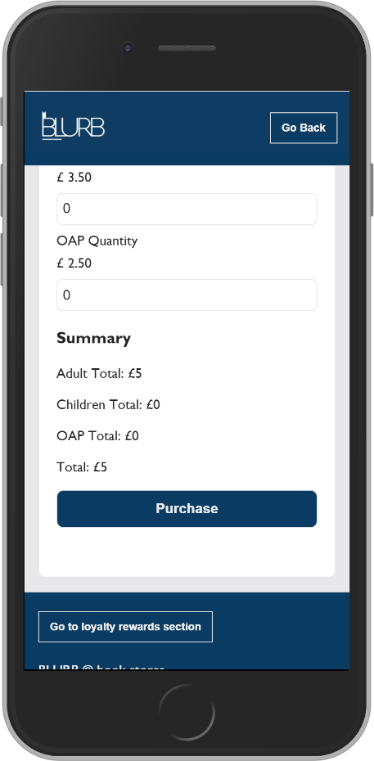

**Booking Page**

The prototype shows infromation about the event on the top e.g. name, location and time. The form is displayed below which shows three input fields that users can enter their personal details. Which are firstname, address and email. There is a button below which redirects users to the payment page.

The final design splits the page into three sections which are: event details, personal details and tickets. The event details are shown at the start, personal details are displayed below which are full name and email and tickets display adult quanity, children quanity and oap quanity. There are diferent prices for the tickets, adults are £5, children are £3.50 and oaps are £2.50. A summary of the costs are shown when the prices are calculated and the total cost is shown below. Once the user clicks the purchase button they will be redirected to the payment page.

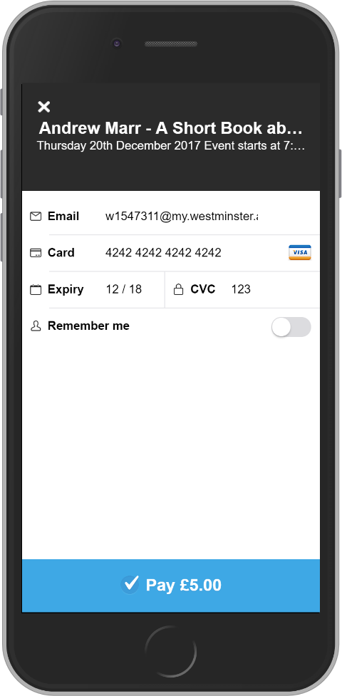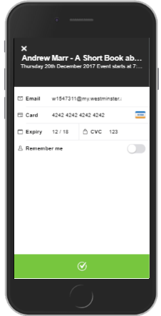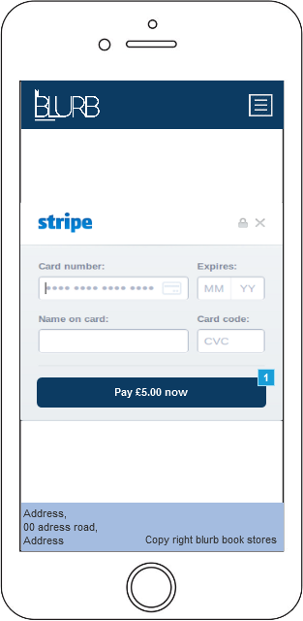

**Payment Page**

The prototype contains a stripe payment api, which allows users to enter their card number, expiry date, name on card and card code.

The final design implements Stripe which had the script on their website. Howver I had to use my own key. The event details within the payment api also the total price which is displayed at the bottom. It also allows users to enter their card number, expiry date, name on card and card code. There is also a option which allows Stripe to remember the users details. Once the user clicks the pay button a green tick will appear indicating the payment was successful. The confirmation message will also appear.

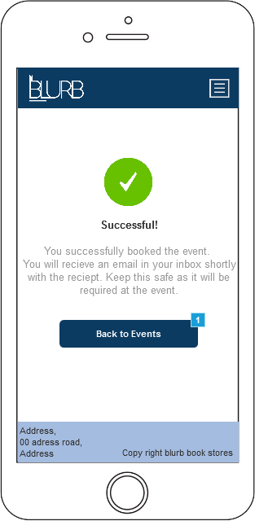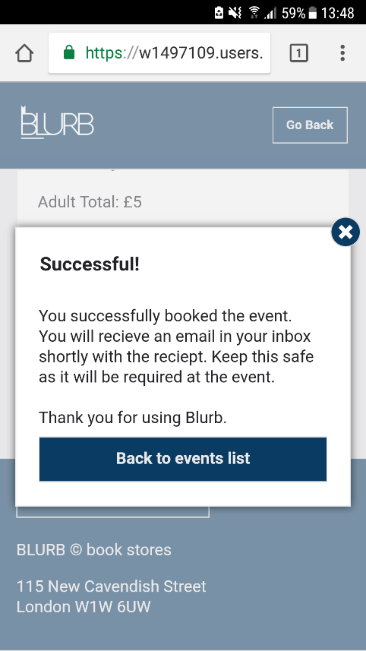

**Payment Confirmation**

The prototype contains a green tick icon which indicates the payment was successful, along with a confirmation message and a button which allows users to go back to the previous page.

The final design does not contain a tick icon as this was implemented within Stripe. The message remains the same as the prototype and is in a pop-up and the button is also implemented wihtin the pop up. There is also an x icon on the top right corner, which allows users to close the message. The font type is calibri and the font colour is black. The succesful is a header, h3.

# Group_5_Student_2_iPhone

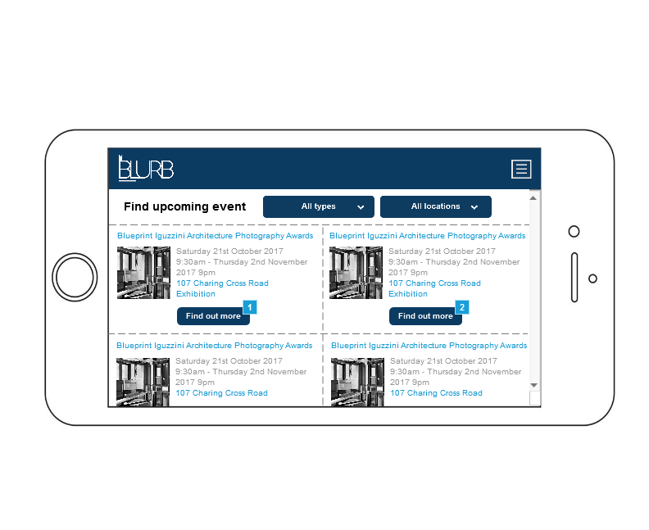As Student 2, I was responsible with the implementation of the proposed design for the events page, the favourites list, and emailing the favourites list to a valid email.



When it came to developing the design for the events page, I went over the designs and felt there was too much text being crammed onto the screen at one time. As well as this, I felt that the structure of the page and how it was formatted looked a bit off. To remedy this I made the following changes below.

**Events Selection Page**

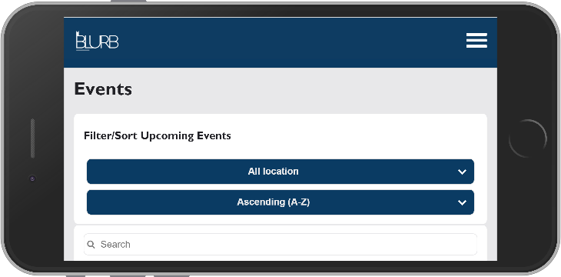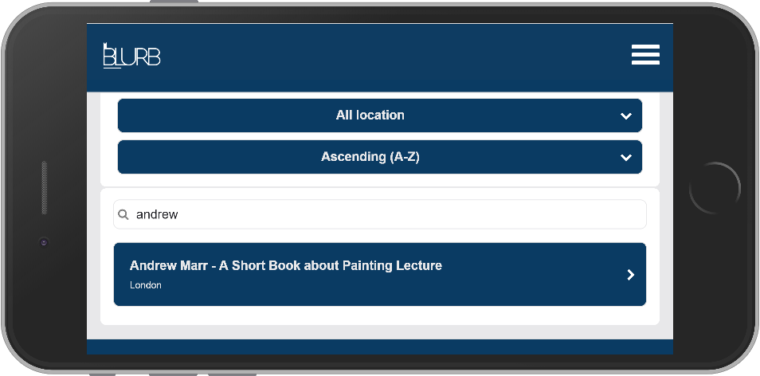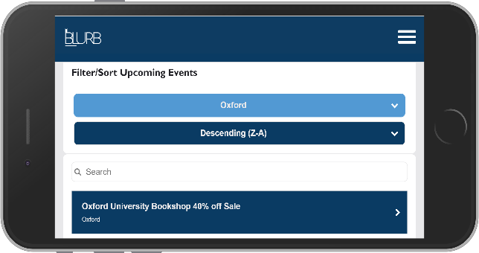

The final design of the Event’s page includes 2 sorting filters which allows the user to sort via location of the event, and via A-Z or Z-A lettering alphabetical-wise – much like how we planned in the prototype (top-left). However, in addition to this we included a search filter which utilises JavaScript to identify a key word typed into the search bar and correlates that with possible events of a similar name (see the above screenshot for the examples I’ve described). Once a user clicks on the desired event, it will take them to a more detailed page about the event in question. This design for the events selection page is effective at how it’s meant to function, with the relatively well sized buttons being easy to press and navigate when held in the landscape orientation by the user.

**Events Description Page**

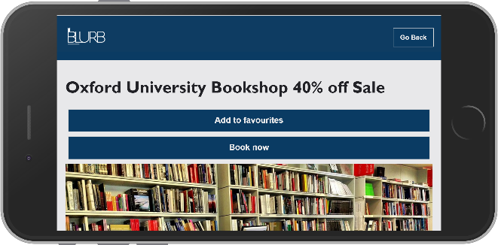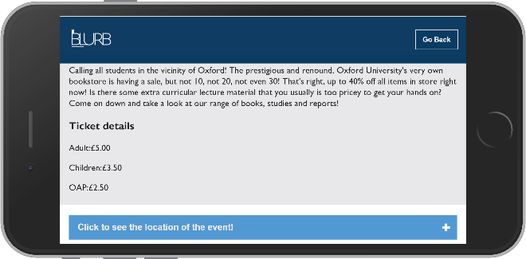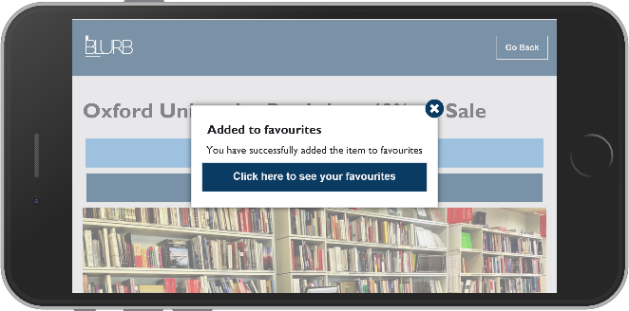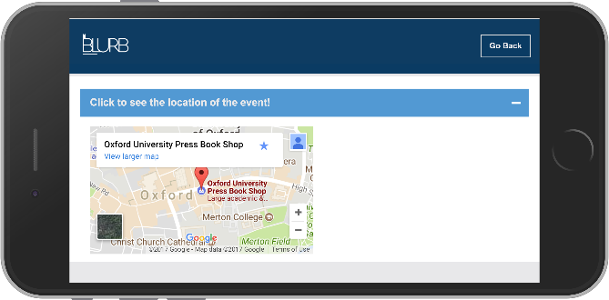

On this page the user will see two buttons, ‘Add to Favourites’ and ‘Book Now’, an image related to the event in question, a description of the event, prices for the event for Children, Adults and OAPs, and a pop-out dropdown option that displays and minimizes the Google Maps API implementation which shows the location of the event. The implementation of the Google API Maps in this way makes it more dynamic and interactive for the user instead of it being static content that’s there on the page. This way the user can choose if they want to see the Google Maps or not, and allows for less clutter on the page.

If the user decides they want to add the event to their favourites list, they would click ‘Add to Favourites’, which displays a popup message telling the user that the event in question has been added to their Favourites list, as well as a link to the Favourites list. If the user wants to then remove this item from their favourites, the ‘Add to Favourites’ button will be replaced with a ‘Remove from Favourites’ button that when clicked does to the opposite – it removes the event in question from the users Favourites list. The user is presented this information in a way that provides the user effective feedback that the actions they performed were successful via the implementation of the popup messages.

If the user would like to book tickets for the event in question, it will take the user to a booking form to book the event, and then a payment page allowing the user to pay for the ticket’s they’ve booked (implemented by Student 1 – further details in their section).

**Favourites Page**

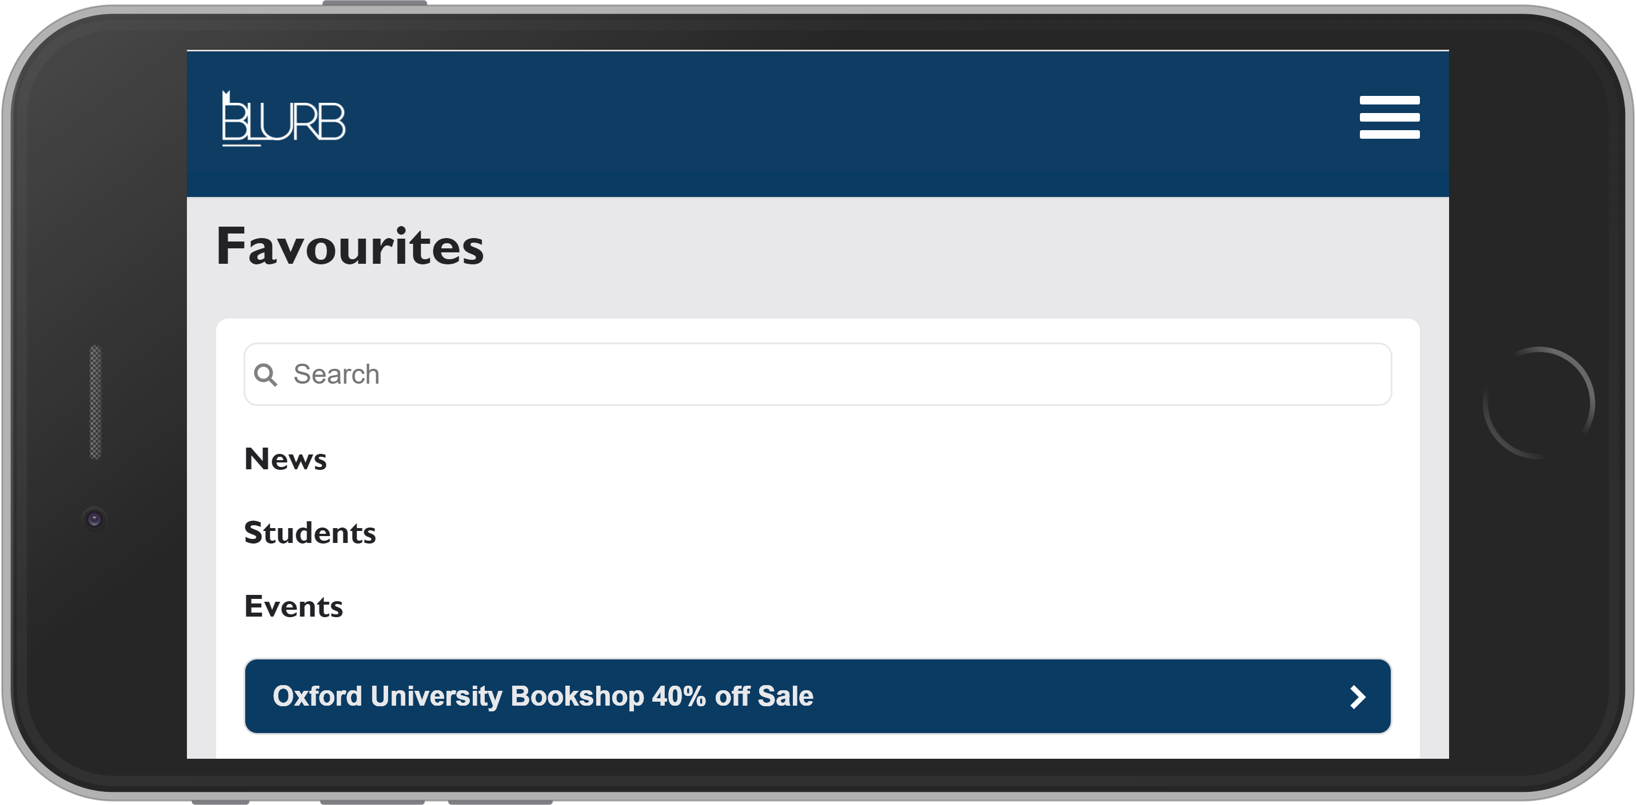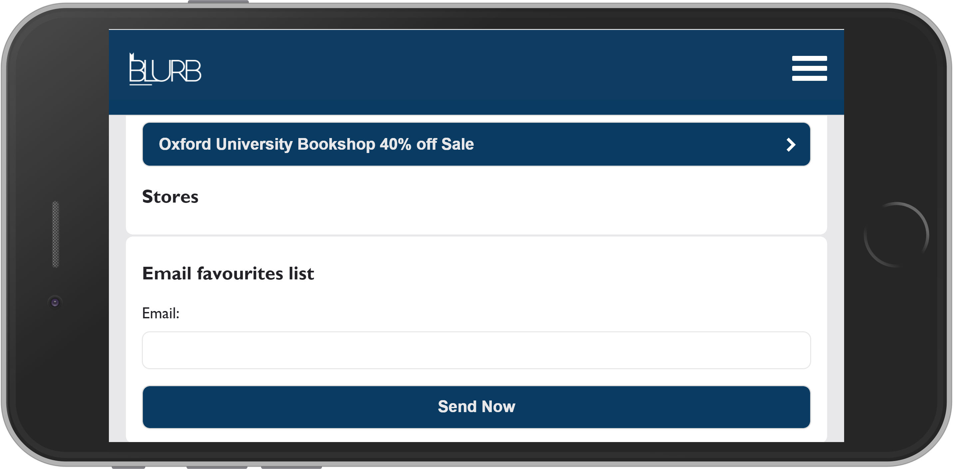

When the user enters the Favourites page, if they have not selected any favourite pages, they will not appear in their relevant category. However, if the user has selected a page as one of their favourites, it will appear for them in its respective category (as seen above). As well as this, the user is also able to click on each favourite that they have selected, and it will redirect them back to its respective detailed description page.

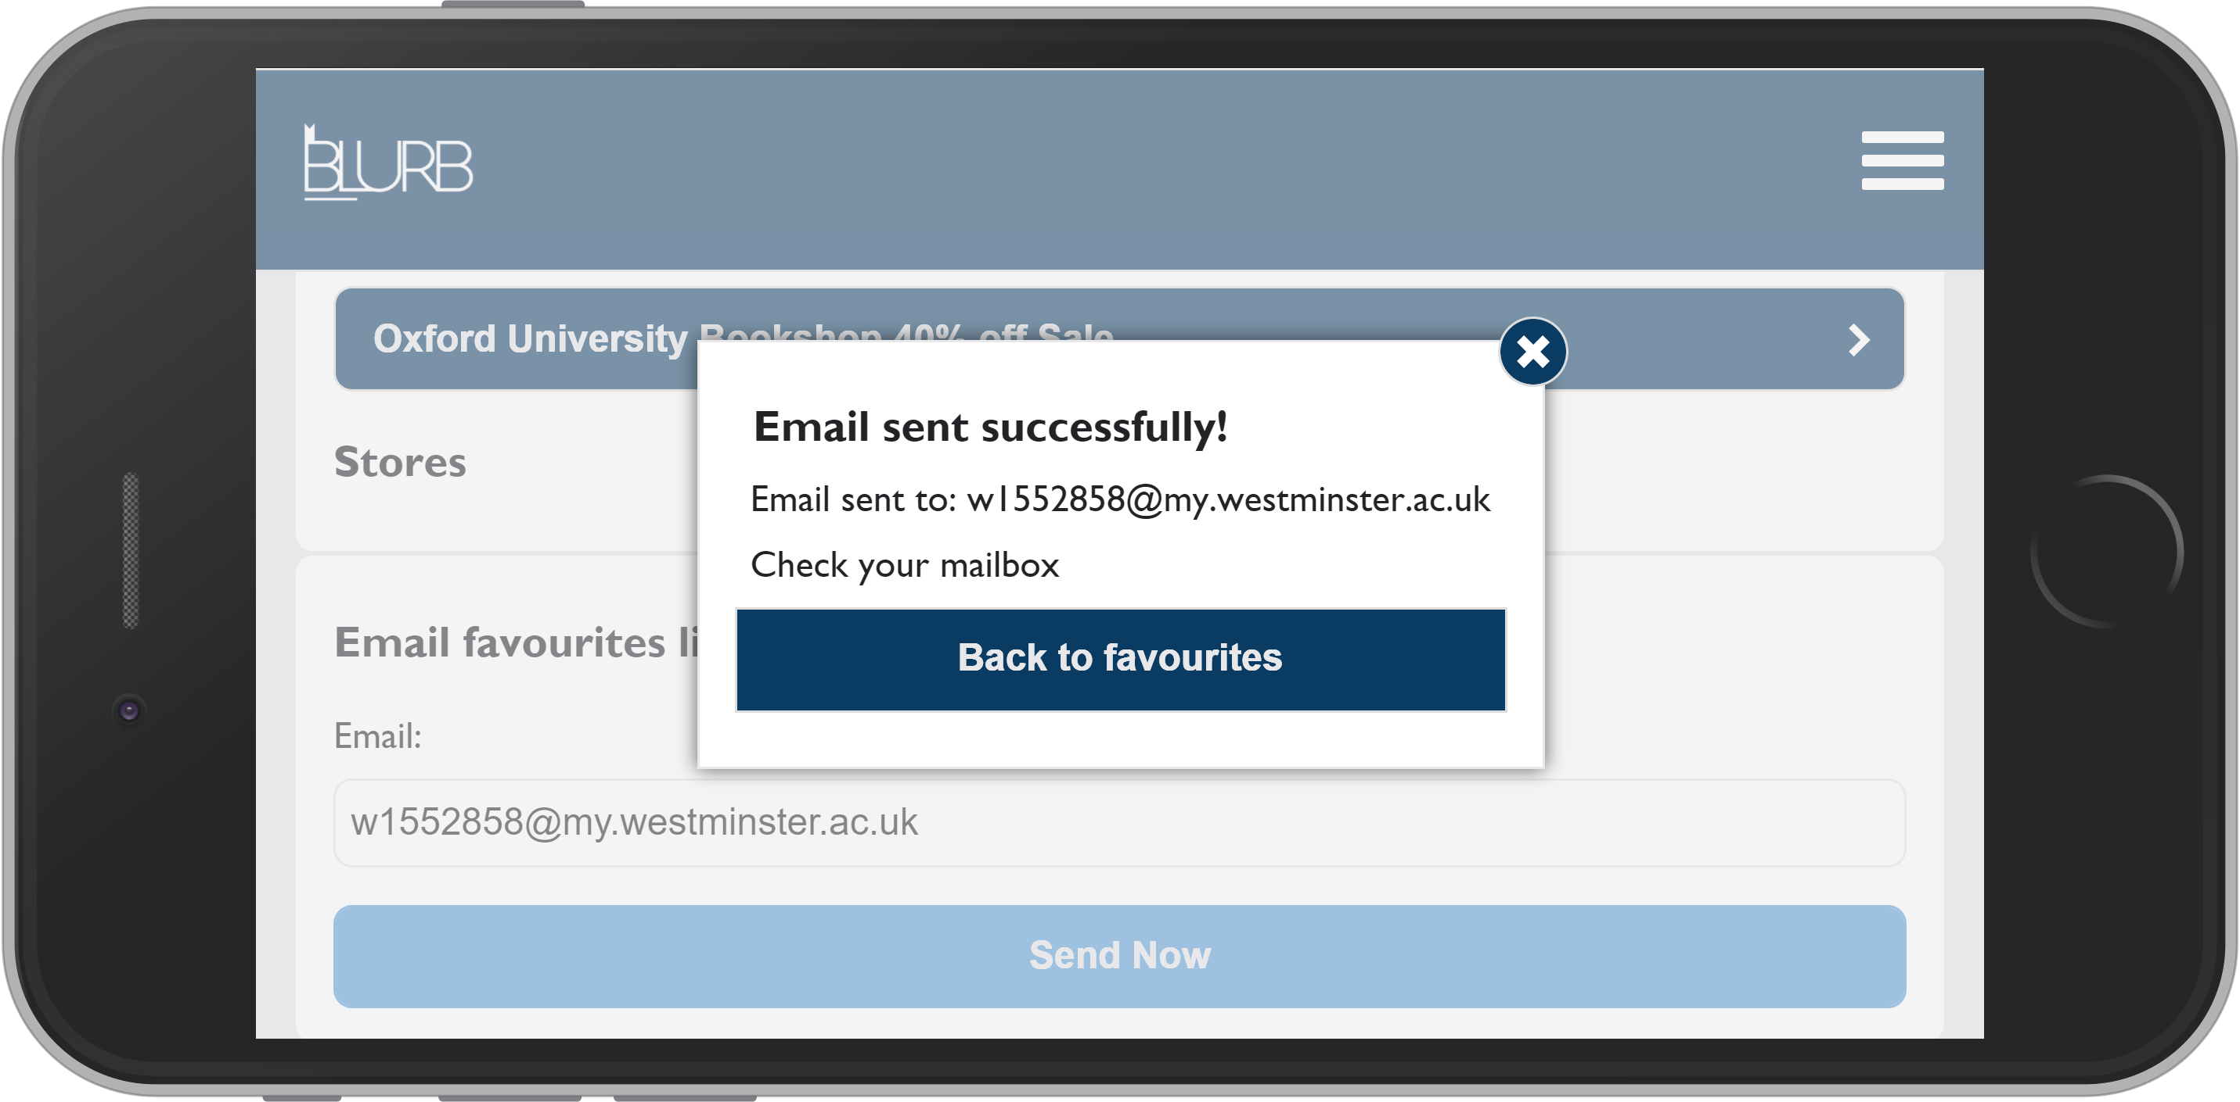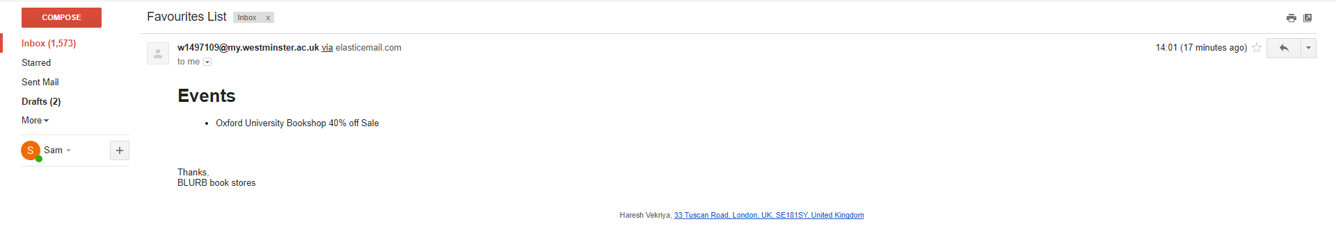

To email the list to a verified email, the user is required to enter their respective valid email address. Once they have done that and clicked ‘Send Now’, the user will again be presented with a popup message that provides the user with feedback that their favourites list was successfully sent to their email. You can also see that it was indeed successful with the screenshot of the email message displayed the correct list item in the email.

# Group_5_Student_3_iPad

-

# Group_5_Student_4_iPad

As student 4, I was responsible with the implementation of the proposed design for showing detailed information about **team members.**

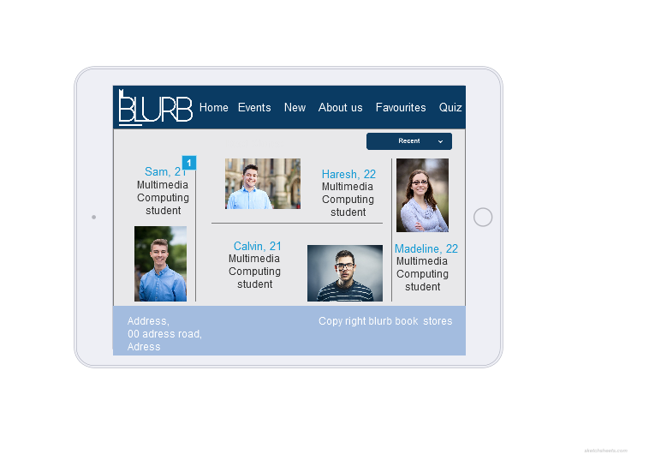.

In the prototype, the “About” section was appearing as shown in the image above. Anyway, as I started to develop the page, I found it really difficult to make it look nicely because I thought it will make the user feel confused about the structure due to the fact that there was a lot of information to be shown in one page without even using the scrolling option. So I decided to create a simple list instead consisted of 4 lines, each of them containing the photo of the team member, his name and age, level, course and his location. The same design is used for the iPad portrait, while the icons disappear when the page is displayed on iPhone, no matter the orientation. As it can be seen below, the scrolling option applies as well. In terms of sorting & filtering, I decided to use a dropdown menu in order to filter the team members by their location. The user is also allowed to sort alphabetically the team members ordering. Underneath the sorting, there is a search bar implemented using JavaScript that allows the user to type some letters in order to filter the results. It needs to be noted the fact that the searching applies to the description and location as well as to the name of the student.

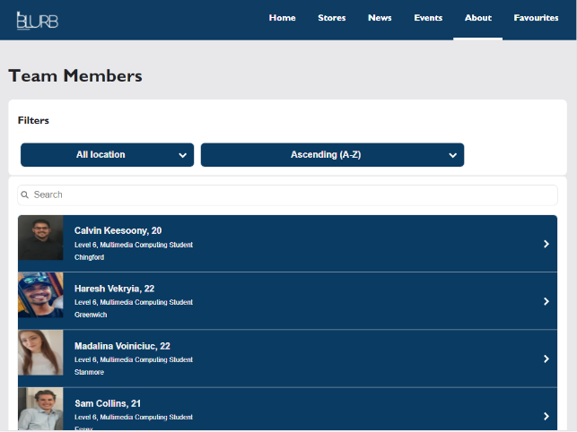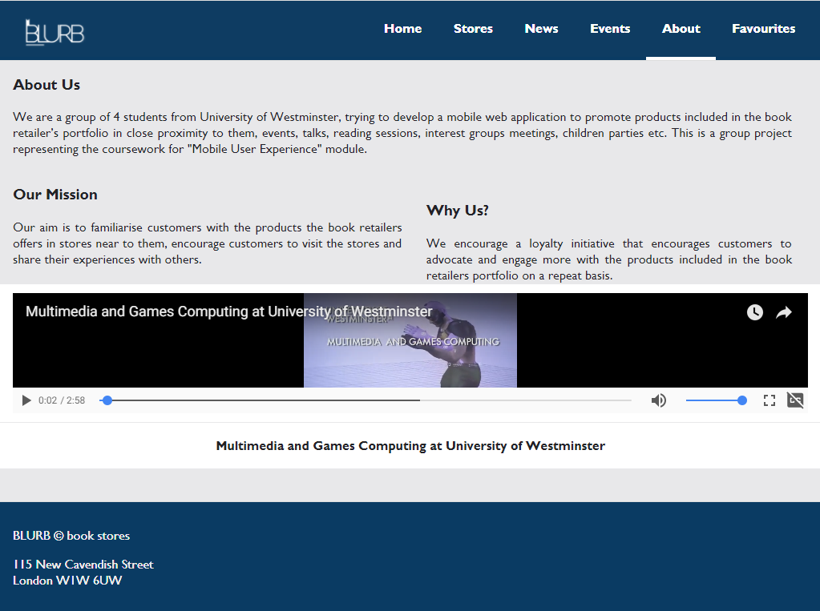

After the list of the team members I thought it would be nice to have some more information about the website so I added three paragraphs consisted into the “About Us”, “Our Mission” and “Why us?”. In the specifications I was also required to incorporate a short video so I embedded one from YouTube called “Multimedia and Games Computing at University of Westminster” so it will be related to our educational background.

The navigation we used was designed by Haresh (student 3) and it was used in both iPad orientations as it was simple and clear. We made it have a fixed position contrary to the footer that we thought it would make the pages look to compact.

Beside the “About” page, I was also responsible with providing a detailed information about each team member. The first idea, shown in the prototype, was changed almost completely in terms of description. I kept the name, age, picture and “Add to favorites” button though.

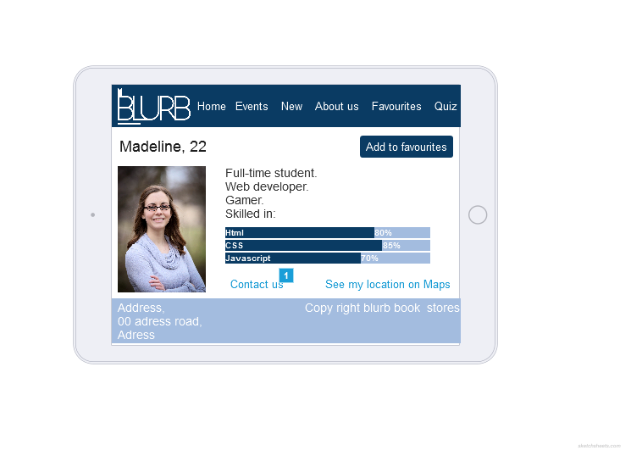

So instead of using only one capture, I implemented this page to have a clear structure and I made use of the scrolling function as well. I replaced the first description idea with a short interview that would allow the user to get to know the team member in a nicer way. Eventually, on the orientation change, the interview will go underneath the picture and the picture will expand to the screen size. Below that, there is a collapsible text saying “Click to see my location on Google Maps” so when the user clicks on that bar, the embedded map will show up allowing the user to see the location as well as to open the map in a new page, on full screen.

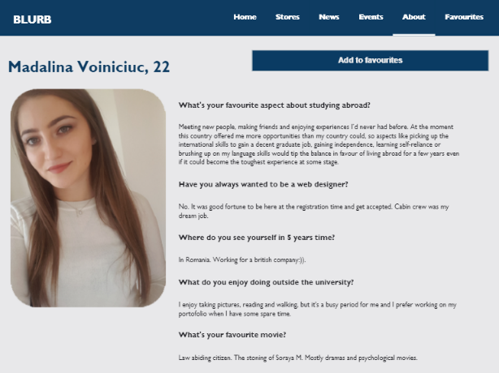 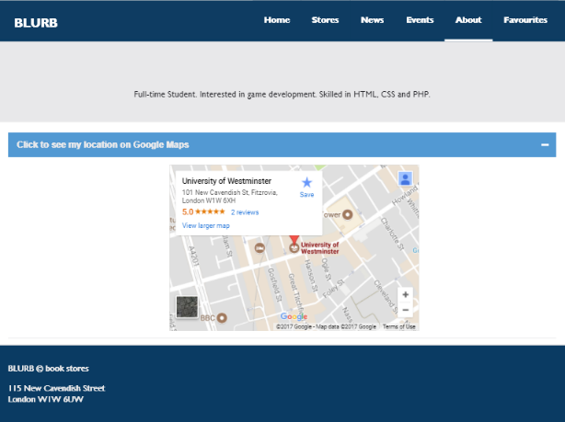

As regards the “Add to favorites” button I implemented here the system response and feedback required so when the button is clicked, a pop-up message will appear informing the user about the fact that that specific team member is added to the favorites list and is also giving him the link to the “Favorites” page. In the pictures below is shown the process of what I just explained. There is going to be one page that will contain all the favorite items around the website. At the end of that page, there is a text box asking for an email address that allows the user to send an email to himself containing the items that he added to his lists.

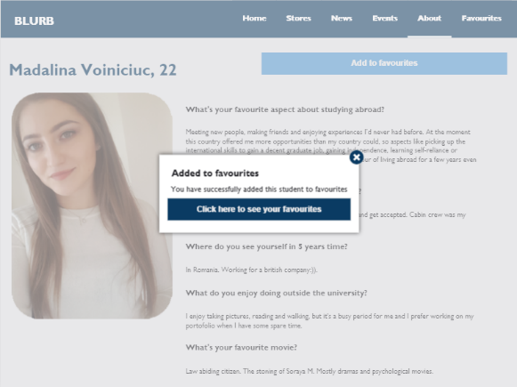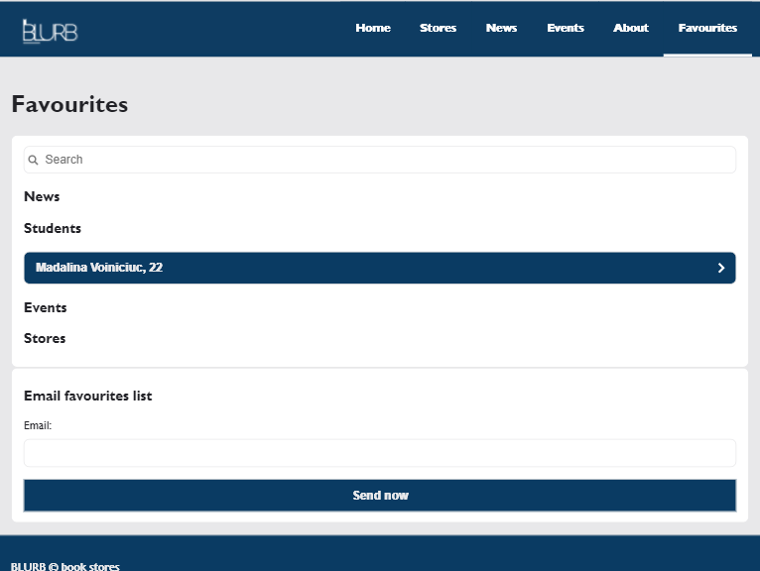

When the user clicks on the item, in this case the student, the student page will show up again, this time having the “Remove from favorites” button active. When clicked, the same pop-up message will show up announcing the user that he successfully removed the student from his favorites list.

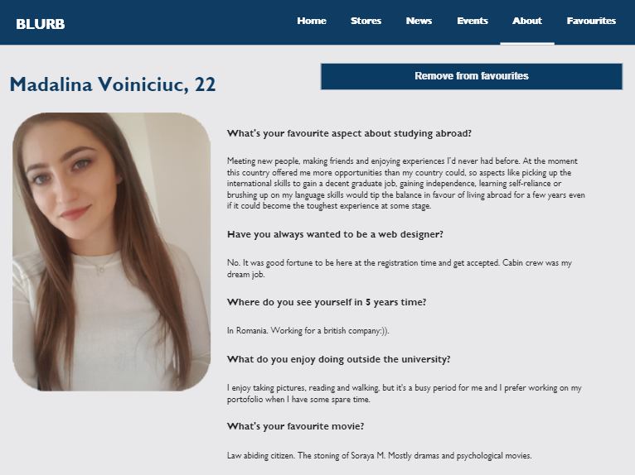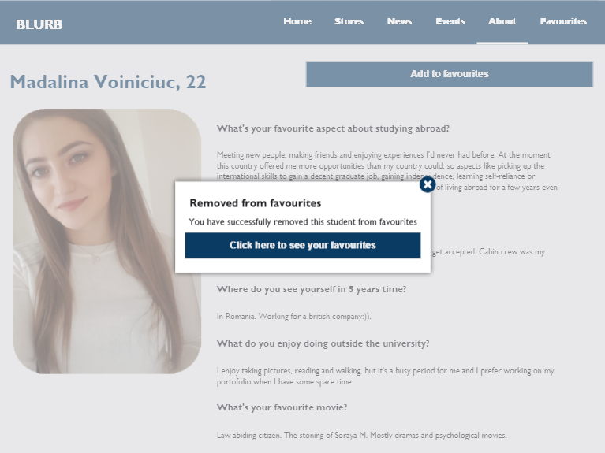

# References

# [University of Westminster](https://www.youtube.com/channel/UCDDiSoWjjf2SMnFMftaD5vg)(2014*) Multimedia and Games Computing at University of Westminster*. Available at: <https://www.youtube.com/watch?v=BaauU5K_gBo> (Accessed: 28 November 2017).